Practical - 7
WEB DEVELOPMENT FRAMEWORKS (ITUE203)
SEMESTER: 3RD, 2026-27
ID: 25DCE110

Practical Title: PHP Form Processing with Server-Side Validation and CSV/JSON File Storage.
Process submitted registration/contact form data using PHP. Validate and sanitize inputs on the server side and store records in CSV or JSON file format. Display success/error messages

Theory
- Is the form submitted using POST?
Yes, the registration form uses the POST method to send user data to registration.php for server-side processing.

- Are inputs validated and sanitized server side?
Yes, PHP validates the submitted inputs using functions such as trim(), empty(), filter_var(), and preg_match() to check that the data is valid and properly formatted.
- Is file writing handled safely?
Yes, the submitted registration data is stored in registration.json using PHP file-handling functions. The LOCK_EX option is used with file_put_contents() to prevent simultaneous write conflicts.
- Are success and error responses displayed clearly?
Yes, success messages are displayed when registration data is stored successfully, and error messages are displayed when validation fails or a storage problem occurs.

Implementation/ Output/Result
Tags:
- HTML Form → Collects student details such as name, enrollment ID, email, mobile number, password, course, year, and gender.
- Form Validation → JavaScript validates the input fields and checks password strength, password confirmation, and terms acceptance.
- POST Request → Uses JavaScript fetch() to send registration data to the PHP backend through a POST request in JSON format.
- Server-Side Validation → PHP validates required fields and checks the formats of the name, enrollment ID, email, mobile number, and password.
- Duplicate Checking → Checks whether the enrollment ID or email already exists in the database.
- Password Security → Uses password_hash() to hash the password before storing it.
- Database Storage → Uses MySQLi prepared statements to insert the validated registration data into the MySQL users table.
- Response Handling → PHP returns JSON success or error messages, which JavaScript displays to the user.

Output Screenshots:
Registration page:
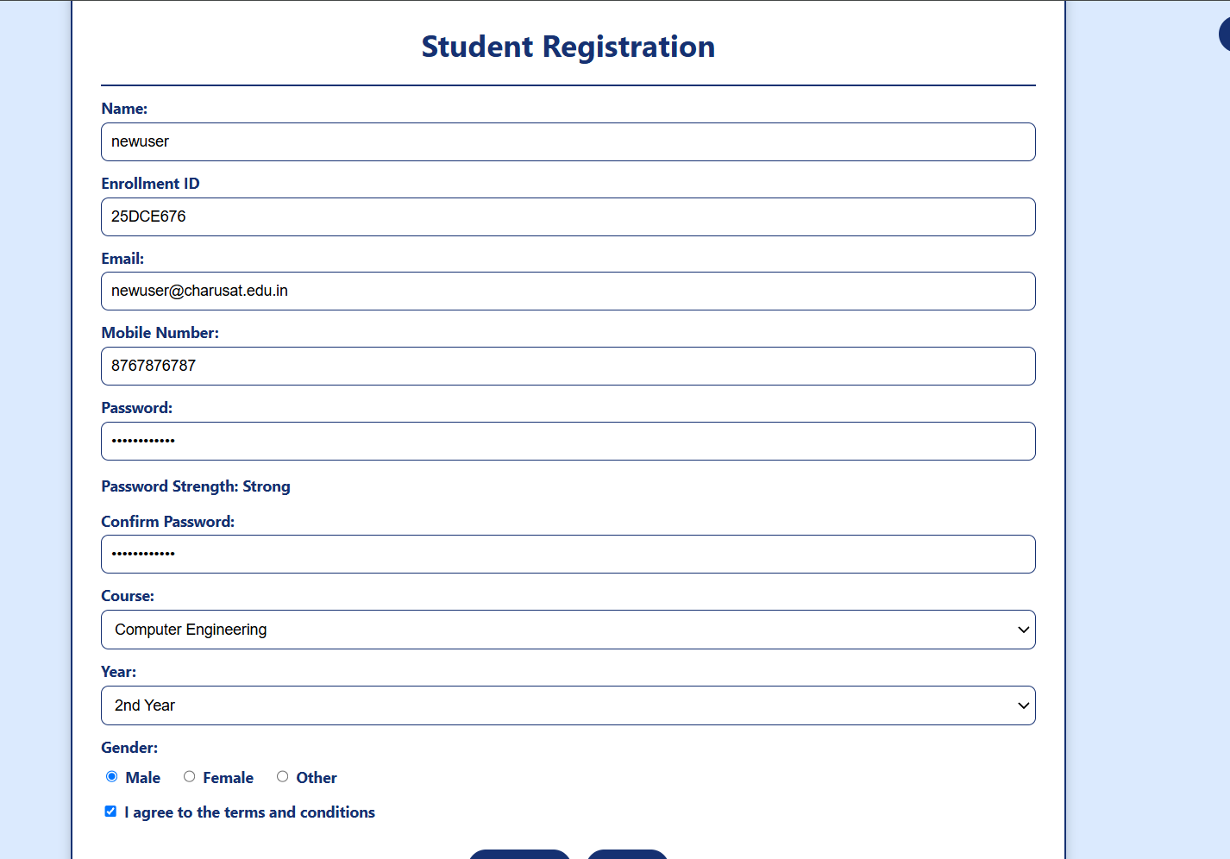
After submit:
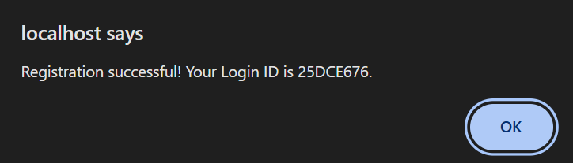

JSON file(New user added):
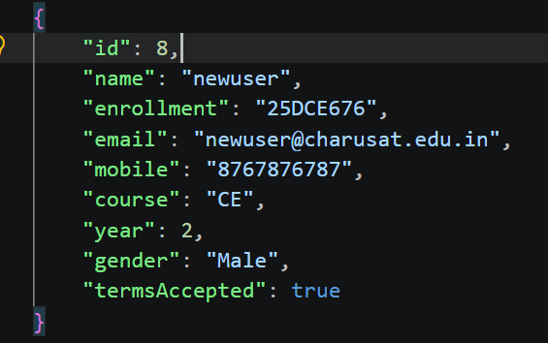

GitHub Repository Link:

https://github.com/kanan2007s-sys/Web-development-/tree/main

Challenges Faced:

It was very difficult to save the data of registration page in JSON file.

Learning Outcomes:
Learned to validate user data securely and store registration details in MySQL and JSON files using PHP, prepared statements, and password hashing.

Faculty Remarks:

